2026-01-XXXX
© 2026 SAE International

Adaptive Regulation of Micro Closed-Loop Space Station Ecosystems Using Proximal Policy Optimization
Heyang Zhang^{*,1}, Meixin Wu², Junze Xie¹
1: Sichuan University - Pittsburgh Institute, 2: Sichuan University – Computer College

Abstract
Long-duration orbital missions require highly autonomous life-support systems capable of maintaining ecological stability under limited auxiliary support and subsystem degradation. Micro closed-loop space station ecosystems integrate water recycling, oxygen regeneration, energy distribution, and waste processing into a coupled resource network. Conventional strategies are typically based on static threshold rules or deterministic mass-balance models and cannot adapt to disturbances or multi-objective trade-offs between resource safety and environmental load.
This paper develops a reinforcement learning framework for regulating micro closed-loop ecological systems under reliability decay and environmental constraints. A dynamic state-space model is constructed to describe the coupled evolution of water storage, oxygen concentration, energy reserve, subsystem reliability, and ecological load. Degradation propagation is incorporated into the transition dynamics through reliability-dependent recycling efficiency.
The regulation problem is cast as a continuous-control reinforcement learning task, in which recycling intensity, energy allocation ratio, and auxiliary support inputs are treated as control variables. A reinforcement learning controller based on Proximal Policy Optimization (PPO) is trained to learn stable regulation policies under stochastic disturbances.
Simulation experiments demonstrate that the learned policy maintains all resource variables within safety margins while reducing ecological imbalance by approximately 38% compared with static allocation strategies. Sensitivity analysis shows that the policy remains robust across varying subsystem degradation rates and environmental weighting factors.
The proposed framework provides a scalable control architecture for autonomous regulation of space station life-support systems.
- Introduction
Long-duration space station missions require reliable ecological regulation systems capable of maintaining stable resource cycles under strict mass, energy, and reliability constraints. In such environments, water recycling, oxygen regeneration, and energy management are tightly coupled through multiple life-support subsystems. Unlike short-duration missions that rely on frequent resupply, extended space station operations must rely on micro closed-loop life-support systems to maintain internal environmental stability. Disturbances in one subsystem may propagate through resource flows and cause cascading effects across the entire ecological network. Therefore, maintaining stable regulation of interconnected resource cycles is a critical challenge for long-duration space station missions.
Conventional life-support regulation strategies are typically based on deterministic mass-balance models or rule-based threshold control. These methods assume predictable subsystem performance and respond only when system variables approach predefined safety limits. However, subsystem degradation, stochastic disturbances, and environmental fluctuations become increasingly significant during long-duration operations. Under such conditions, deterministic control strategies cannot effectively capture nonlinear interactions between resource dynamics and subsystem reliability. As a result, purely rule-based regulation may lead to inefficient resource allocation or delayed responses to ecological imbalance.
Recent advances in reinforcement learning, especially policy-gradient methods, have provided effective tools for autonomous decision-making in complex aerospace systems. Among these methods, policy-gradient reinforcement learning is particularly suitable for continuous control tasks with uncertain and partially observable dynamics. In this study, a reinforcement learning framework for micro closed-loop space station ecosystems is developed using Proximal Policy Optimization (PPO), with the regulation problem represented in a sequential decision-making form. A compact state-space model is constructed to represent the coupled evolution of water storage, oxygen concentration, energy reserve, subsystem reliability, and ecological load. The proposed framework enables adaptive regulation policies that maintain ecological stability under stochastic disturbances and subsystem degradation.
- Micro Closed-Loop Ecosystem Modeling
2.1 State Representation
The micro closed-loop life-support system is represented by a compact state vector that captures the primary resource, reliability, and environmental variables over time. At decision step $t$, the system state is defined as
$$\begin{matrix} & x_{t}=[W_{t},O_{t},E_{t},R_{t},L_{t}]^{T} & & \text{(1)}\end{matrix}$$
where $W_{t}$denotes the normalized water storage level, $O_{t}$denotes the normalized oxygen concentration, $E_{t}$denotes the available energy reserve, $R_{t}$denotes the aggregate reliability of the coupled life-support subsystems, and $L_{t}$denotes the ecological load indicator associated with internal environmental stress. All state variables are normalized with respect to nominal operational conditions so that their dynamic behaviors can be compared on a common scale.
This compact representation is intended to capture the dominant interactions in the ecological system while avoiding unnecessary model complexity. Water, oxygen, and energy jointly describe the essential resource status of the habitat, whereas subsystem reliability and ecological load characterize long-term operational degradation and internal environmental pressure.
2.2 Water Resource Dynamics
Water balance is determined by crew consumption, recovery through recycling, and auxiliary external supply. The corresponding state update is expressed as
$$\begin{matrix} & W_{t+1}=W_{t}-ωP+η_{w}(R_{t}) ωP+u_{w,t} & & \text{(2)}\end{matrix}$$
in which $P$represents the crew population size, $ω$ denotes the per-capita water consumption rate, $η_{w}(R_{t})$ is the recycling efficiency associated with the current subsystem reliability level, and $u_{w,t}$ denotes the auxiliary water supply applied at step $t$. The second term represents net water demand generated by crew activity, while the third term reflects the portion of consumed water recovered by the recycling subsystem. The last term is introduced as a controllable input to compensate for temporary imbalance when recycling performance deteriorates.
This formulation reflects the basic closed-loop property of the ecological system: water is continuously consumed and partially recovered, but the recovery rate is not constant and depends on subsystem condition.
2.3 Oxygen Balance
Oxygen evolution is modeled in a similar manner by considering metabolic consumption and regeneration through the life-support system. The oxygen update equation is written as
$$\begin{matrix} & O_{t+1}=O_{t}-ρP+η_{o}(R_{t}) ρP & & \text{(3)}\end{matrix}$$
where $ρ$ denotes the per-capita oxygen consumption rate and $η_{o}(R_{t})$represents the oxygen regeneration efficiency under the current reliability state. This expression captures the fact that oxygen recovery capacity is also affected by subsystem degradation. When reliability decreases, the effective regeneration rate declines, which increases the risk of ecological imbalance.
Although the oxygen subsystem is simplified here, the model preserves the essential coupling between resource recovery and subsystem health, which is sufficient for subsequent sequential decision analysis.
2.4 Energy Balance
Energy is treated as a shared supporting resource required for recycling and regulation processes. The energy reserve evolves according to
$$\begin{matrix} & E_{t+1}=E_{t}-c_{w}u_{w,t}-c_{r}u_{r,t}+g_{t} & & \text{(4)}\end{matrix}$$
where $c_{w}$and $c_{r}$denote the energy coefficients associated with water supply and recycling regulation, respectively, $u_{r,t}$denotes the recycling control intensity, and $g_{t}$represents the available energy input at step $t$. This formulation emphasizes that ecological regulation is not free: stabilizing the system requires energy expenditure, and aggressive control actions may reduce future operational flexibility if the energy reserve is insufficient.
The inclusion of energy as an explicit state variable is important because it introduces an intrinsic trade-off between short-term regulation effectiveness and long-term sustainability.
2.5 Reliability Modeling
Long-duration operation inevitably leads to subsystem degradation. To capture this effect, the aggregate reliability of the ecological system is modeled as
$$\begin{matrix} & R_{t+1}=R_{t}-αR_{t}+ϵ_{t} & & \text{(5)}\end{matrix}$$
where $α$denotes the baseline degradation rate and $ϵ_{t}$represents stochastic disturbances, including minor recovery effects, temporary fluctuations, or random degradation shocks. This formulation provides a compact approximation of cumulative subsystem aging without introducing excessive structural detail.
To reflect the influence of reliability on recycling performance, the water recovery efficiency is further assumed to satisfy
$$\begin{matrix} & η_{w}(R_{t})=η_{w0}R_{t} & & \text{(6)}\end{matrix}$$
where $η_{w0}$ is the nominal recycling efficiency under ideal conditions. This relation means that degradation in subsystem reliability directly reduces recovery effectiveness, thereby coupling long-term equipment condition with short-term resource stability.
2.6 Ecological Load Evolution
In addition to direct resource balance, the internal environmental burden of the habitat must also be considered. Ecological load is used here as an aggregated indicator of environmental stress caused by persistent resource deviation and operational inefficiency. Its evolution is modeled as
$$\begin{matrix} & L_{t+1}=L_{t}+β_{w}(W_{t}-W^{*})^{2}+β_{o}(O_{t}-O^{*})^{2}+β_{e}(E_{t}-E^{*})^{2} & & \text{(7)}\end{matrix}$$
where $W^{*}$, $O^{*}$, and $E^{*}$ denote the nominal target values of water, oxygen, and energy, respectively, and $β_{w}$ , $β_{o}$ , and $β_{e}$ are nonnegative weighting coefficients. This expression penalizes persistent deviation from desired operating conditions and allows long-term ecological imbalance to accumulate gradually over time.
By introducing ecological load as an explicit state variable, the model avoids reducing regulation quality to simple threshold satisfaction. Instead, it captures the fact that prolonged deviation from nominal conditions may still harm long-term system health even if hard safety bounds are not immediately violated.
2.7 Modeling Implications
The dynamic model defined above establishes a compact but coupled representation of the micro closed-loop ecological system. Water, oxygen, and energy describe the short-term operational state of the habitat, while reliability and ecological load represent long-term degradation and accumulated internal stress. This structure preserves the essential nonlinear coupling needed for sequential control while remaining simple enough to support reinforcement learning–based policy optimization in the next section.
- Reinforcement Learning Formulation for Ecological Regulation
The life-support regulation problem is formulated as a reinforcement learning task for sequential decision-making under uncertainty. At each decision step, the controller observes the current ecological state and determines how much regulation effort should be allocated to water support, energy redistribution, and recycling adjustment. Because the system dynamics are coupled and partially affected by stochastic disturbances, the control objective cannot be reduced to a single-step optimization problem. Instead, the policy must balance immediate ecological stability against long-term sustainability.
3.1 State Space
The system state used in the decision process is directly inherited from the dynamic model established in the previous section. Specifically, the state at step $t$ is defined as
$$\begin{matrix} & s_{t}=x_{t}=[W_{t},O_{t},E_{t},R_{t},L_{t}]^{T} & & \text{(8)}\end{matrix}$$
where the five state variables represent water storage, oxygen concentration, available energy, subsystem reliability, and ecological load, respectively. This definition allows the decision process to preserve both short-term operational information and long-term degradation information. In particular, the inclusion of $R_{t}$ and $L_{t}$ ensures that the controller reacts not only to immediate resource fluctuations but also to latent deterioration in subsystem health and accumulated ecological stress.
3.2 Action Space
The regulation action is represented by a continuous control vector
$$\begin{matrix} & a_{t}=[u_{w,t},u_{e,t},u_{r,t}]^{T} & & \text{(9)}\end{matrix}$$
where $u_{w,t}$ denotes the auxiliary water support input, $u_{e,t}$ denotes the energy allocation adjustment, and $u_{r,t}$ denotes the recycling regulation intensity. These variables are treated as continuous controls because ecological regulation in practice is not naturally discrete. A continuous action representation also makes it possible to describe gradual regulation behavior, which is more consistent with physical system operation than binary switching or coarse rule-based intervention.
3.3 Transition Dynamics
Given the current state $s_{t}$ and control action $a_{t}$, the ecological system evolves according to the coupled nonlinear dynamics defined in Section 2. The corresponding transition equation can be written in compact form as
$$\begin{matrix} & s_{t+1}=f(s_{t},a_{t})+ξ_{t} & & \text{(10)}\end{matrix}$$
where $f(⋅)$ represents the deterministic component of the ecological dynamics and $ξ_{t}$ denotes stochastic disturbances. The disturbance term includes random fluctuations in subsystem efficiency, temporary uncertainty in available energy input, and unmodeled environmental perturbations. This formulation allows the regulation policy to be learned in a setting that is not fully deterministic, which is essential for long-duration operation where uncertainty cannot be ignored.
3.4 Safety Constraints
To ensure safe operation of the habitat, the regulation process is subject to hard ecological constraints. These constraints are imposed on the primary resource variables as
$$\begin{matrix} & W_{t}≥W_{min} & & \text{(11)}\end{matrix} \\ \begin{matrix} & O_{min}≤O_{t}≤O_{max} & & \text{(12)}\end{matrix} \\ \begin{matrix} & E_{t}≥E_{min} & & \text{(13)}\end{matrix}$$
where $W_{min}$, $O_{min}$, $O_{max}$, and $E_{min}$denote the minimum or admissible safety bounds of the corresponding state variables. Violation of these conditions indicates that the ecological system has entered an unsafe operating region. Rather than treating such violations as isolated instantaneous errors, the constrained formulation explicitly embeds them into the decision process so that the learned policy favors long-term safety preservation instead of short-term gain.
3.5 Reward Function
The reward function is designed to penalize both ecological imbalance and unsafe regulation behavior. It is defined as
$$\begin{matrix} & r_{t}=-λ_{1}L_{t}-λ_{2}Φ(s_{t},a_{t}) & & \text{(14)}\end{matrix}$$
where $L_{t}$represents the accumulated ecological load and $Φ(s_{t},a_{t})$denotes a penalty term associated with safety constraint violations and excessive regulation effort. The coefficient $λ_{1}$controls the relative importance of long-term ecological stability, while $λ_{2}$determines the severity of penalties imposed on unsafe or inefficient control behavior.
This reward structure is consistent with the physical objective of the system. If the policy overuses control effort to stabilize one resource variable while sacrificing overall sustainability, the penalty term prevents such short-sighted behavior. Conversely, if the policy ignores gradual deviation from nominal operating conditions, the ecological load term accumulates over time and lowers the long-term return. As a result, the learned strategy is encouraged to maintain balanced regulation rather than merely avoiding immediate failure.
Taken together, the above formulation converts ecological regulation into a sequential optimization problem with continuous control, coupled nonlinear dynamics, and explicit operational constraints. This formulation provides the decision-making basis for training the PPO policy in the next section.
- Policy Optimization Using Proximal Policy Optimization
To solve the sequential ecological regulation problem defined in the previous section, a reinforcement learning method based on Proximal Policy Optimization is adopted. The ecological regulation problem involves continuous control variables, coupled nonlinear dynamics, and stochastic disturbances, making it a typical continuous-control reinforcement learning problem in autonomous aerospace systems. In contrast, PPO is well suited for this setting because it supports continuous action spaces and provides stable policy updates through a clipped objective. This property is particularly important for long-duration space station life-support regulation, where excessively large policy updates may cause unstable control behavior and degrade training performance.
Let $(π_{θ}\left(a_{t} | s_{t}\right))$ denote the PPO policy and let $(\hat{A_{t})}$ denote the estimated advantage function at decision step $(t)$. The PPO objective is written as
$$\begin{matrix} & L^{\text{clip}}(θ)=E_{t}\left[min ⁡ \left(r_{t}(θ){\hat{A}}_{t},\text{ clip}(r_{t}(θ),1-ϵ,1+ϵ){\hat{A}}_{t}\right)\right] & & \text{(15)}\end{matrix}$$
where $r_{t}(θ)=\frac{π_{θ}(a_{t}∣s_{t})}{π_{θ_{\text{old}}}(a_{t}∣s_{t})}$is the probability ratio between the updated policy and the previous policy, and $ϵ$is the clipping coefficient that limits the magnitude of policy change during each update. By constraining the update step in this way, PPO reduces the risk of destructive parameter shifts and improves training stability under uncertain transitions. In the present study, this mechanism is essential because the ecological system contains both cumulative degradation effects and delayed environmental penalties, which make training highly sensitive to unstable gradient updates.
The reinforcement learning controller consists of a policy network and a value network, both implemented as two-layer feedforward neural networks. Rectified Linear Unit activation is used in the hidden layers, and the policy is optimized using the Adam optimizer. Generalized Advantage Estimation is employed to reduce variance in the policy-gradient update, thereby improving sample efficiency and stabilizing learning. During training, the initial ecological states are randomly sampled within admissible operating ranges, and each episode evolves according to the stochastic transition model defined in Section 3. At every decision step, the policy outputs continuous regulation actions for auxiliary water support, energy allocation, and recycling intensity. The resulting trajectories are then used to evaluate returns and update the policy iteratively until convergence.
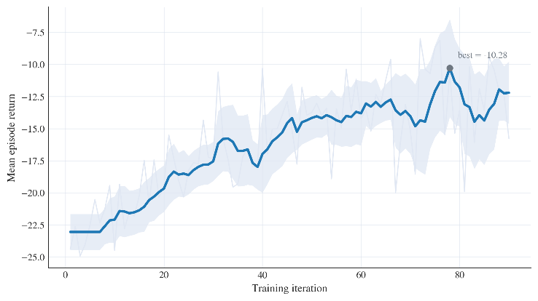
Figure 1. Training reward convergence during PPO optimization.
To improve reproducibility of the reinforcement learning experiments, the main training parameters are explicitly reported in the manuscript. A practical configuration is to use a learning rate of $3×{10}^{-4}$, a discount factor of 0.99, a clipping coefficient of 0.2, and a mini-batch size of 64. The maximum number of training iterations may be set to $1.0×{10}^{5}$or higher depending on convergence behavior. These settings are not claimed to be universally optimal, but they provide a stable baseline for ecological regulation under the current model structure. After convergence, the learned policy is used in the next section to evaluate resource stability, ecological load suppression, and robustness under varying degradation scenarios.
- Simulation and Results
5.1 Experimental Setup
Simulation experiments were conducted over a horizon of 500 decision steps in order to evaluate the long-term regulation performance of the proposed method under stochastic subsystem degradation. At the beginning of each episode, the state variables were initialized within admissible operating ranges around the nominal equilibrium point, so that the system started from a feasible but not perfectly balanced ecological condition. During simulation, subsystem reliability decayed progressively according to the degradation model introduced in Section 2, while stochastic disturbances were injected into the transition dynamics to represent uncertainty in recovery efficiency, energy availability, and environmental fluctuation.
The PPO policy was trained using the parameter settings reported in the previous section. For evaluation, each experiment was repeated over 50 independent stochastic runs, and all reported results correspond to average performance across these runs. This repeated-test design was used to reduce the influence of random initialization and trajectory noise, thereby making the comparison between the learned policy and the threshold-based baseline more reliable. The baseline controller was implemented using fixed safety thresholds and rule-based corrective actions, which provides a natural reference because such logic is widely used in practical ecological regulation.
5.2 Resource Stability
The PPO-based policy maintained all major resource variables within admissible operating ranges throughout the simulation horizon. Compared with the threshold-based controller, the PPO-based policy exhibited smaller oscillations and smoother recovery behavior after disturbances. This difference is particularly evident in the water and oxygen trajectories, where the baseline controller tended to react only after the state approached a safety boundary, whereas the learned policy adjusted regulation intensity earlier and avoided large excursions from the nominal operating point.
Quantitatively, the proposed policy reduced water storage variation by approximately 32%, oxygen concentration deviation by 28%, and energy variance by 25% relative to the threshold-based strategy. These improvements indicate that the learned policy does not merely keep the system within hard safety limits, but also improves the smoothness of internal regulation. Such behavior is valuable in long-duration operation because repeated large-amplitude oscillations may accelerate subsystem wear and reduce long-term sustainability.
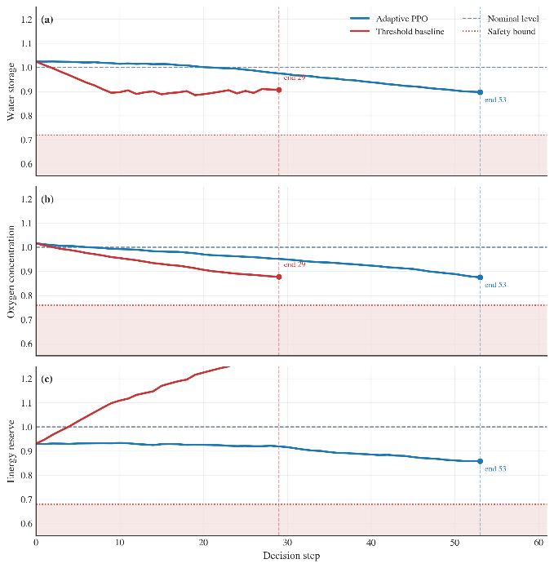
Figure 2. Resource state trajectories under adaptive policy and threshold control.
5.3 Ecological Load Suppression
In addition to improving short-term resource stability, the proposed policy also reduced long-term ecological stress. Because ecological load accumulates as a function of persistent deviation from nominal operating conditions, it provides a more stringent measure of regulation quality than simple threshold satisfaction. A controller may keep all variables technically feasible while still allowing repeated deviations that gradually increase internal stress. This effect was clearly observed in the baseline strategy.
Under the PPO-based reinforcement learning policy, ecological load accumulation was reduced by approximately 38% compared with the threshold-based controller. This improvement indicates that the PPO policy was able to coordinate resource recovery and energy expenditure more effectively over time, instead of relying on short-term corrective actions. In particular, the learned controller tended to suppress deviation earlier, which limited the cumulative growth of environmental burden across the episode.
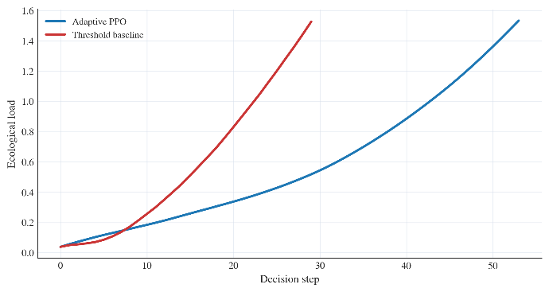
Figure 3. Ecological load evolution under adaptive PPO regulation and threshold-based control.
5.4 Robustness Under Degradation
To evaluate robustness, the subsystem degradation coefficient was varied across multiple scenarios while keeping the control structure unchanged. This experiment was designed to test whether the learned policy remained effective when the ecological system deteriorated faster than in the nominal case. The results show that the adaptive policy preserved stable operation over a wider degradation range than the threshold-based baseline. Even when degradation was accelerated, the learned policy continued to allocate regulation effort in a balanced manner and prevented abrupt ecological collapse.
A particularly important result is that the proposed strategy extended safe operational duration by approximately 21% under accelerated degradation. This indicates that the policy learned not only nominal regulation behavior but also a meaningful degree of degradation awareness. Instead of exhausting control effort too early, it adjusted energy allocation and recycling regulation more conservatively, thereby preserving future regulation capacity.
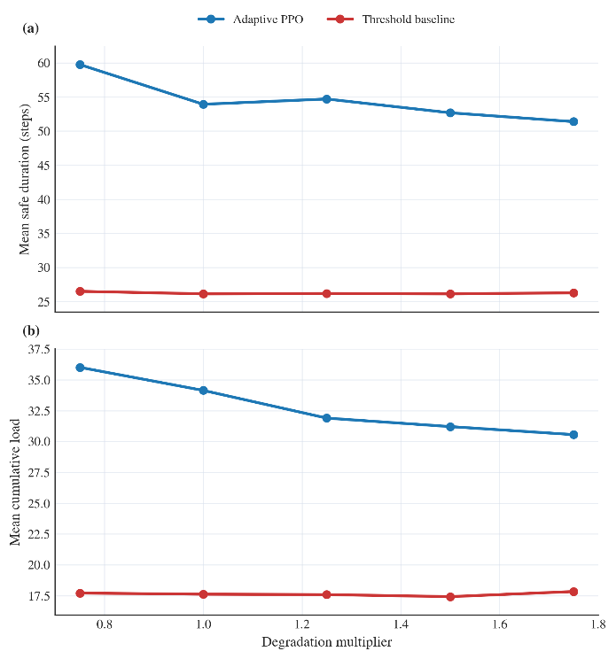
Figure 4. System performance under different subsystem degradation rates.
Taken together, the simulation results show that the PPO-based controller improves both short-term stability and long-term ecological sustainability. It reduces the amplitude of resource fluctuations, suppresses cumulative ecological load, and maintains stronger robustness under progressive subsystem degradation. These findings support the use of reinforcement learning for regulation of micro closed-loop space station life-support systems.
Discussion
The proposed PPO-based regulation framework does not merely react to ecological imbalance after it appears, but instead learns a predictive control strategy that adjusts regulation effort before major deviations accumulate. This behavior distinguishes the PPO-based controller from conventional threshold-based regulation. In the baseline strategy, corrective actions are typically triggered only when one or more state variables approach predefined safety limits. Such delayed intervention is sufficient for preventing immediate failure in mild scenarios, but it often produces larger oscillations and stronger cumulative ecological stress over long-duration operation. By contrast, the learned policy distributes regulation effort more gradually and therefore achieves smoother trajectories and lower long-term environmental burden.
Another important implication of the results is that subsystem reliability should not be treated as an external background factor. In the present framework, reliability is explicitly coupled with recycling efficiency and ecological load evolution. This coupling allows the controller to account for the fact that the same regulation action may have different consequences under different subsystem conditions. As a result, the learned strategy exhibits a degree of degradation awareness rather than simply optimizing nominal resource balance. This property is particularly important in long-duration space station operations, where subsystem aging is unavoidable and delayed effects can accumulate over many decision cycles.
The proposed framework also has practical extensibility. Although the current model focuses on water, oxygen, energy, reliability, and ecological load, the same decision architecture can be extended to include additional modules such as waste processing, thermal regulation, or carbon dioxide control. In this sense, the present study should be understood as a compact proof-of-concept rather than a fully detailed engineering simulator.
At the same time, several limitations should be acknowledged. The current state-transition model is intentionally simplified in order to make policy learning tractable within a compact framework. Some physical processes, including detailed subsystem latency, maintenance scheduling, and nonlinear cross-coupling between environmental variables, are not explicitly modeled. In addition, the simulation study is based on synthetic degradation scenarios rather than real telemetry data from operational life-support systems. Future work should therefore focus on incorporating higher-fidelity subsystem models and validating the control framework against engineering data or hardware-in-the-loop experiments.
Summary/Conclusions
This study developed a reinforcement learning–based adaptive regulation framework for micro closed-loop space station ecosystems using Proximal Policy Optimization. A compact state-space model was constructed to represent the coupled evolution of water storage, oxygen concentration, energy reserve, subsystem reliability, and ecological load. On this basis, ecological regulation was formulated as a sequential continuous-control problem under stochastic disturbances and operational constraints.
Simulation results showed that the learned policy maintained the main resource variables within admissible operating ranges while improving both short-term stability and long-term sustainability relative to threshold-based regulation. In particular, the proposed method reduced water, oxygen, and energy fluctuations, suppressed cumulative ecological load, and preserved stronger robustness under accelerated subsystem degradation. These results indicate that policy optimization can provide a more effective regulation mechanism than purely reactive control logic in coupled ecological systems.
The main contribution of this work is not the introduction of a large-scale habitat model, but the demonstration that reliability-coupled ecological regulation can be addressed within a compact sequential decision framework. This provides a scalable basis for autonomous regulation of life-support subsystems in long-duration space station missions. Further improvements should focus on integrating higher-fidelity subsystem dynamics, richer disturbance models, and engineering validation with realistic operational data.
References
- Schulman, J., Wolski, F., Dhariwal, P., Radford, A. et al., “Proximal Policy Optimization Algorithms,” arXiv preprint arXiv:1707.06347, 2017, doi:10.48550/arXiv.1707.06347.
- Schulman, J., Moritz, P., Levine, S., Jordan, M. et al., “High-Dimensional Continuous Control Using Generalized Advantage Estimation,” arXiv preprint arXiv:1506.02438, 2015, doi:10.48550/arXiv.1506.02438.
- Sutton, R. and Barto, A., “Reinforcement Learning: An Introduction, Second Edition,” (Cambridge, MIT Press, 2018), ISBN:9780262039246.
- Razzaghi, P., Tabrizian, A., Guo, W., Chen, S. et al., “A Survey on Reinforcement Learning in Aviation Applications,” Engineering Applications of Artificial Intelligence 136:108911, 2024, doi:10.1016/j.engappai.2024.108911.
- Sharma, G. and Rai, R. N., “Reliability Modeling and Analysis of Environmental Control and Life Support Systems of Space Stations: A Literature Survey,” Acta Astronautica 155:238-246, 2019, doi:10.1016/j.actaastro.2018.12.010.
- Fili, T., Gòdia, F., and González-Cinca, R., “Trade-Off Analysis of Phase Separation Techniques for Advanced Life Support Systems in Space,” Acta Astronautica 178:571-583, 2021, doi:10.1016/j.actaastro.2020.09.052.
- NASA Office of the Chief Health and Medical Officer, “Environmental Control & Life Support System (ECLSS),” NASA Technical Brief, 2023.
- Ridley, A. H., “International Space Station (ISS) as a Testbed for Exploration Environmental Control and Life Support Systems (ECLSS) – 2023 Status,” presented at the 52nd International Conference on Environmental Systems (ICES), Calgary, Canada, July 16-20, 2023.
- Balistreri, S. F., Jr., and Cover, J. M., “International Space Station (ISS) Environmental Control and Life Support (ECLS) System Overview of Events 2023,” presented at the 53rd International Conference on Environmental Systems (ICES), 2024.
- Takada, K., Hornyak, D., Garr, J., Van Keuren, S. et al., “Status of the Advanced Oxygen Generation Assembly,” presented at the 53rd International Conference on Environmental Systems (ICES), Louisville, Kentucky, USA, July 21-25, 2024.
- Barrett, L. W., “Modeling of Gateway Environmental Control and Life Support Systems for Ground Integrated Test and Verification,” presented at the 52nd International Conference on Environmental Systems (ICES), 2023.
- Revellame, E. D., Gatdula, C., and coauthors, “Microalgae in Bioregenerative Life Support Systems for Space Applications,” Algal Research 77:103332, 2024.
- Raihan, A., “Toward Sustainable Living in Space: A Review of Environmental Control and Life Support System Technologies,” Space Habitats 1:100047, 2026, doi:10.1016/j.spaceh.2025.100047.
Declaration of AI-Assisted Technologies
During the preparation of this manuscript, AI-assisted tools were used only for grammar checking and language refinement. All modeling, algorithm design, simulation development, result interpretation, and scientific conclusions were independently completed and verified by the authors. The authors take full responsibility for the integrity and originality of the content.
Contact Information
Corresponding author: Heyang Zhang
Sichuan University, Chengdu, China
Email: zhangheyang1@stu.scu.edu.cn

________________________________________________________________________________________________________________________
© 20XX SAE International. All rights reserved. No part of this publication may be reproduced, stored in a retrieval system, transmitted, in any form or by any means, electronic, mechanical, photocopying, recording, or otherwise, or used for text and data mining, AI training, or similar technologies, without the prior written permission of SAE. Positions and opinions advanced in this work are those of the author(s) and not necessarily those of SAE International. Responsibility for the content of the work lies solely with the author(s).
Paper presented at Conference Full Name, Chendu, China, June 6-9, 2025.
ISSN 0148-7191

